Case 18-AM,C-Taino-Tri-pointer-Type 1-Elongated Base-Rounded Crest

**Origin:** Dominican Republic  
**Circa:** 1200 AD to 1500 AD   
**Dimensions:** 7.125" (18.1cm) high x 4.25" (10.8cm) wide x 10.75" (27.3cm) depth   
**Collection:** Pre-Columbian

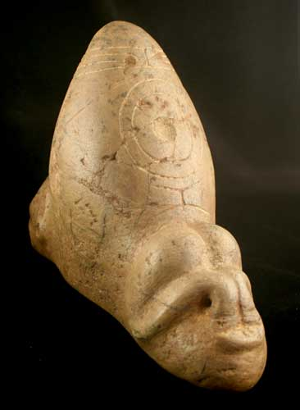 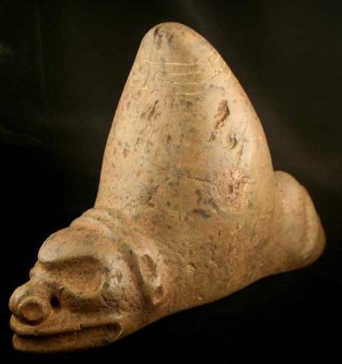

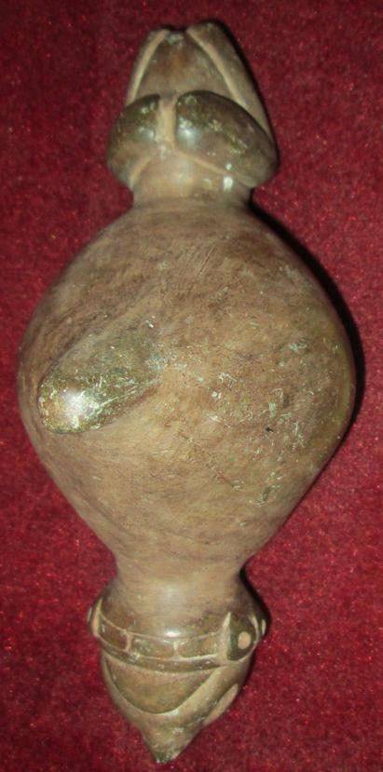 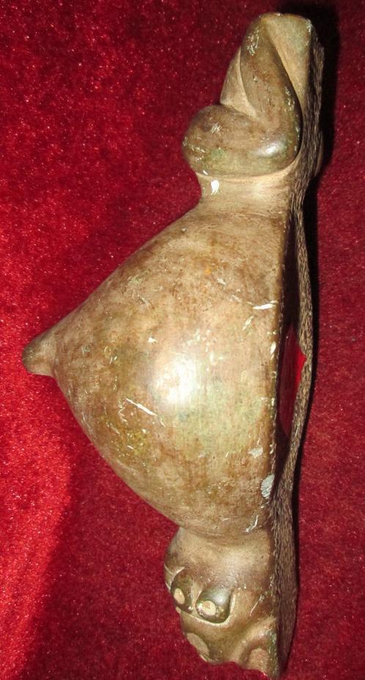

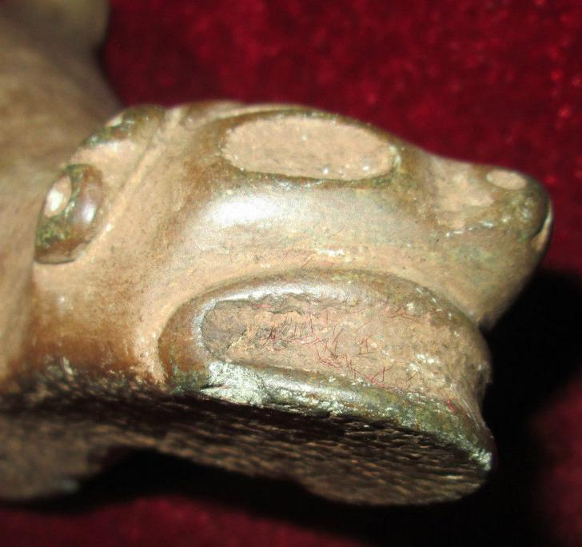 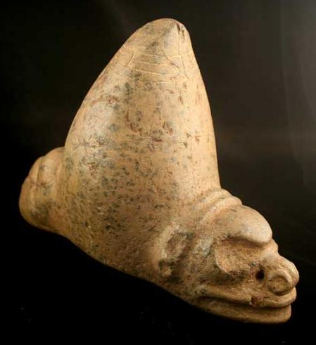

This trigonolitos, or three-pointer, represents a popular art form among the Taino. This culture flourished in the Caribbean between c.1200-1500, before the Spanish conquest disrupted its existence. The precise function of these triangular objects is unknown although it is clear that they were used for ceremonial purposes. Although the Caribbean islands had been populated for centuries before the Taino heyday, a new level of political organization was achieved during this period. Three-pointers, along with stone collars and elbow stones, were owned by the caciques or chieftains as symbols of their power. The central cone of these triangular objects has been interpreted in a variety of ways. Suggestions include manioc shoots (one of the main crops of the Taino), volcanoes, and the roofs of Taino houses, phalluses and the human breast. None of these theories has been universally accepted and the precise origins of the shape are likely to remain a mystery. Despite this, many scholars agree that these ceremonial objects were symbols of power and fertility. This seems to be supported by a letter written by Columbus in which he reports on his findings among the Taino, ‘Equally the majority of caciques (chiefs) have three stones to which they and their people have great devotion. One they say is for the fertility of the grain and vegetables that they grow; the next for mothers to give birth without pain, and the third for the water and sun when they have need.’

Both ends of this example are carved in the form of a zoomorphic face. It was a fairly common practice amongst Taino craftsmen to combine multiple representations of anthropomorphic or zoomorphic figures on the same object, often arranged in such a way that both faces are not visible from the same angle. The religious or spiritual significance of such objects cannot be precisely defined in the absence of a written tradition. The Taino believed in the existence of a supreme god or creator called Yucahu Maorocoti and a fertility goddess called Attabeira. Ancestor worship was also fundamental to their belief system. Images of the gods and spirits were created in wood, bone, shell and stone and are referred to collectively as zemís. This example clearly had spiritual associations for its first owner and our inability to define them closely only contributes to its sense of mystery. - (CK.0600)

The Taino flourished in the Caribbean between c.1200-1500. They were the first Americans to make contact with the Spanish in 1492 and to suffer as a result. Their predecessors, who migrated to the islands from both South America and Mesoamerica, first used many of the features today associated with the Taino, such as ball-courts and three-pointers. As society became more organized under the Taino, the political system increased in complexity and agricultural production intensified. Artistic creativity also flourished. Earlier three-pointers were often undecorated and small in size. During the Taino heyday they became increasingly important to public ritual and therefore larger and more intricate. The central cone of these triangular objects has been interpreted in a variety of ways. Suggestions include manioc shoots (one of the main crops of the Taino), volcanoes, and the roofs of Taino houses, phalluses and the human breast. None of these theories has been universally accepted and the precise origins of the shape are likely to remain a mystery. Despite this many scholars agree that these ceremonial objects were symbols of power and fertility. This is supported by a letter written by Columbus in which he reports on his findings among the Taino, ‘Equally the majority of caciques (chiefs) have three stones to which they and their people have great devotion. One they say is for the fertility of the grain and vegetables that they grow; the next for mothers to give birth without pain, and the third for the water and sun when they have need.’

Taino stone carvings were worked with two types of tool: bone and flint chisels and a taut chord that cut through the stone with the aid of water and fine sand. The creator of this three-pointer obviously delighted in the natural veining of the pale green/cream stone. The anterior end depicts a face that has both anthropomorphic and zoomorphic features. The sunken circular eye-sockets and the wide mouth could be human but the nose resembles a snout. Behind the face is a band of geometric designs. A second band of lightly incised interlocking triangles runs up the vertical axis and down the other side. The posterior end is carved with a pair of hunched, frog-like legs. This position is found on other Taino artifacts – including pestles that depict figures in a crouching pose. It seems to represent a trance-like state that was brought on by the inhalation of the hallucinogenic cohoba. Although the mystery of the function of three- pointers remains to be solved, they offer a unique insight into the spiritual lives of the Taino people. (AM) - (AM.0083)